1.87: The best way to show these results is to use the result of part (a) of Problem 1-65, a restatement of the law of cosines. We know that

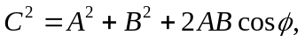
where is the angle between 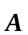 and 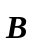.

a) If 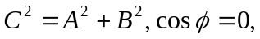and the angle between and is 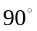(the vectors are perpendicular).

b) If 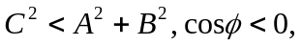 and the angle between and is greater than.
c) If 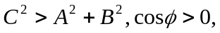and the angle betweenand is less than .

